**CS 1150 Design Notebook Required Sections**

**Step 1: Problem Statement**

This assignment will have me read a file and create parrot-like objects and use those parrots to fill a binary tree. The binary tree will be created from a class and will have specific methods to take in parrot objects. It will use a node with life and right pointers and will be organized by separating small and big values into left and right sides. From the tree, the code will display a hidden song by going through the tree in level order and after will display only the leaf nodes.

**Step 2: Understandings**

* What I Know:
  + Method
  + Objects
  + Comparable Interface
* What I Don’t Know:
  + Creating a Binary Tree

**Step 3: Pseudocode and pictures**

Main:

* Create BinaryTree object
  + new BinnaryTree()
* Create File and Scanner for File
  + File file = new File(parrot.txt)
  + Scanner fileRead = new Scanner(file)
* Go through file and create parrot objects
  + Use while and hasNext()
* Call levelOrder Method in BinaryTree Class
* Call visitLeaves Method In BinaryTree Class

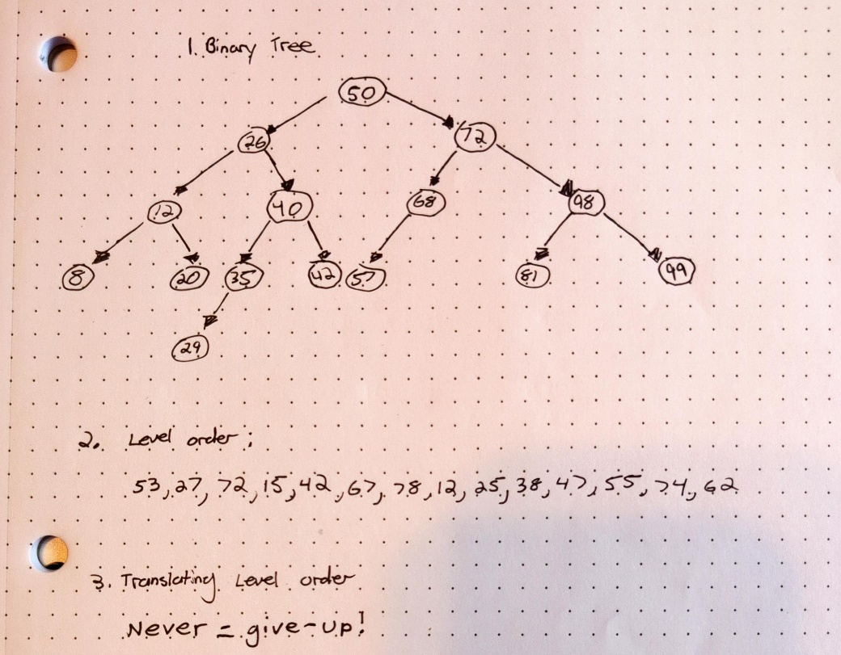

**Step 4: Lesson Learned**

I was having an issue with creating parrot objects because it would get stuck creating parrot objects. I realized it was because I had my if statement checking for > or < 1 and but the id for the parrot was 93 and the head node id was 94 so the returned value was one so it did not go into either if statement, I changed them to be < or > 0 and also added a else statement for the possibility of equal values.

**Step 5: Code**

**import java.io.File;**

**import java.io.FileNotFoundException;**

**import java.util.LinkedList;**

**import java.util.Queue;**

**import java.util.Scanner;**

**/\***

**Isaiah Hoffer**

**CS1450 (M/W)**

**5/1/25**

**Assignment 10**

**This assignment will make me create my own binary tree and fill its nodes with parrot objects.**

**It will use java's comparable interface to organize tree. Parrot objects are created from the given file.**

**\*/**

**public class HofferIsaiahAssignment10 {**

**public static void main(String[] args) throws FileNotFoundException {**

**//Creating BinaryTree**

**BinaryTree parrotTree = new BinaryTree();**

**//Creating And Scanning File**

**File parrotFile = new File("parrots.txt");**

**Scanner parrotRead = new Scanner(parrotFile);**

**//Read FIle Until No More Text**

**while(parrotRead.hasNext()) {**

**int parrotID = parrotRead.nextInt(); //Gets ID Of Parrot**

**String parrotName = parrotRead.next(); //Gets Name Of Parrot**

**String parrotLyric = parrotRead.nextLine().trim(); //Gets Parrot Song Word**

**//Creating And Insterting Parrot To Binary Tree**

**parrotTree.insert(new Parrot(parrotID, parrotName, parrotLyric));**

**}//While**

**//Caling LevelOrder Method**

**//Pretext**

**System.*out*.printf("Parrot's Song\n"**

**+ "-------------------------------------------\n");**

**parrotTree.levelOrder();**

**//Calling visitLeaves Method**

**//Pretext**

**System.*out*.printf("\n\nParrots On Leaf Nodes\n"**

**+ "-------------------------------------------\n");**

**parrotTree.visitLeaves();**

**//Closing Scanner**

**parrotRead.close();**

**}//main**

**}//class**

**//Parrot Object To Hold Id, Name, And Song Lyric**

**class Parrot implements Comparable<Parrot> {**

**//Private Data**

**private int id; //Holds Parrot ID**

**private String name; //Holds Parrots Name**

**private String songWord; //Hold Parrto's Lyric For Song**

**public Parrot(int id, String name, String songWord) {**

**//Initalizing Data**

**this.id = id;**

**this.name = name;**

**this.songWord = songWord;**

**}//Parrot Constructor**

**//Getter To Return Name**

**public String getName() {**

**return name;**

**}//GetName Method**

**//Getter For SongWord**

**public String sing() {**

**return songWord;**

**}//Sing Method**

***@Override***

**public int compareTo(Parrot otherParrot) {**

**return this.id - otherParrot.id;**

**}//compareTo Method**

**}//Parrot Class**

**class BinaryTree {**

**//Private Data**

**TreeNode root; //Head Of Tree**

**public BinaryTree() {**

**//Initalizing Private Data**

**this.root = null;**

**}//BinaryTree Constructor**

**//Adds Parrot To Tree, Returns True Or False**

**public boolean insert(Parrot parrotToAdd) {**

**//Creating Node**

**TreeNode treeNode = new TreeNode(parrotToAdd);**

**//Boolean Variable**

**Boolean didInsert = false;**

**if(root == null) {**

**root = treeNode;**

**}//If**

**else {**

**TreeNode current = root;**

**while(!didInsert) {**

**//Left Side**

**if(parrotToAdd.compareTo(current.parrot) < 0) {**

**if(current.left == null) {**

**current.left = treeNode;**

**didInsert = true;**

**}//If**

**else {**

**current = current.left;**

**}//Else**

**}//If**

**//Right Side**

**else if(parrotToAdd.compareTo(current.parrot) > 0) {**

**if(current.right == null) {**

**current.right = treeNode;**

**didInsert = true;**

**}//If**

**else {**

**current = current.right;**

**}//Else**

**}//Else If**

**//Do Not Insert --- Duplicate Value**

**else didInsert = false; //Else**

**}//While**

**}//Else**

**return didInsert;**

**}//Insert Method**

**//Traverse Tree, Prints Parrot's Lyric**

**public void levelOrder() {**

**if(root != null) {**

**//Creating Queue**

**Queue<TreeNode> nodeQueue = new LinkedList<>();**

**//Adding Root To Queue**

**nodeQueue.offer(root);**

**while(!nodeQueue.isEmpty()) {**

**TreeNode current = nodeQueue.remove();**

**System.*out*.printf("%s ",current.parrot.sing());**

**//Adding Left Node**

**if(current.left != null) {**

**nodeQueue.offer(current.left);**

**}//If**

**//Adding Right Node**

**if(current.right != null) {**

**nodeQueue.offer(current.right);**

**}//If**

**}//While**

**}//If**

**}//levelOrder Method**

**//Calls Private visitLeaves Class**

**public void visitLeaves() {**

**visitLeaves(this.root);**

**}//VisitLeaves Public Method**

**//Recusive Method To Display Only Leaves**

**private void visitLeaves(TreeNode aNode) {**

**//Only Traverse Filled Nodes**

**if(aNode != null) {**

**visitLeaves(aNode.left); //Goes All Left**

**if(aNode.left == null && aNode.right == null) { //Checks If Node Is Leaf**

**System.*out*.println(aNode.parrot.getName());**

**}**

**visitLeaves(aNode.right); //Go To Right As Climbing Back Up**

**}//While**

**}//VisitLeaves Private Method**

**private class TreeNode {**

**//Private Data**

**Parrot parrot; //Hold Parrot Object**

**TreeNode left; //Pointer To Go Left Of Tree**

**TreeNode right; //Pointer To Go Right Of Tree**

**public TreeNode(Parrot parrot) {**

**//Initalizing Private Data**

**this.parrot = parrot;**

**this.left = null;**

**this.right = null;**

**}//TreeNode Constructor**

**}//TreeNode Private Class**

**}//BinaryTree Class**